**A Project Report**

**on**

**“Mini Piano”**

Submitted in Partial Fulfillment of the Requirement Of

Project-III (BIT206CO)

of

Bachelor of Information Technology

**Submitted to:**



Purbanchal University

Biratnagar, Nepal

**Submitted by:**

Nirendra Mananda Bajracharya (333701)

Pranam Rai(333704)

Santosh Kumar Yadav(333714)

**KIST COLLEGE**

Kamalpokhari, Kathmandu

April 30, 2023

**A Project Report**

**On**

**“Mini Piano”**

Submitted in Partial Fulfillment of the Requirement Of

Project-III (BIT206CO)

Of

Bachelor of Information Technology

**Submitted to:**

Purbanchal University

Biratnagar, Nepal

**Submitted by:**

Nirendra Mananda Bajracharya (333701)

Pranam Rai(333704)

Santosh Kumar Yadav(333714)

**Project Supervisor**

**Kiran Khanal**

**KIST COLLEGE**

Kamalpokhari, Kathmandu

April 30, 2023

**CERTIFICATE OF TOPIC APPROVAL SHEET**

It is hereby informed that the topic selected by Nirendra Mananda Bajracharya (333701), Pranam Rai(333704) and Santosh Kumar Yadav(333714) of the BIT third semester project has been found suitable and as per the credit assigned by Purbanchal University (PU), Biratnagar, Nepal. The Project Committee has approved the following topic and supervisor for the mentioned students. This project has been completed for the prescribed period and the project embodied the result of their investigation conducted during they worked as a full-time students of this institution.

Topic Approved: **Mini Piano**

_____________________ _____________________

Mr. Deepak khadka Mr. Kiran Khanal

HOD, Department of Information Technology Project Supervisor

Kist College Kist College

**DECLARATION**

We declare that this project report titled **Mini Piano** submitted in partial fulfillment of the Bachelor of Information Technology is a record of original work carried out by us under the supervision of Kiran Khanal and has not formed the basis for the award of any other degree or diploma, in this or any other Institution or University. In keeping with the ethical practice in reporting scientific information, due acknowledgments have been made wherever the findings of others have been cited.

With regards,

Nirendra Mananda Bajracharya (333701)

Pranam Rai(333704)

Santosh Kumar Yadav(333714)

**SUPERVISOR’S APPROVAL**

This is to certify that the major project entitled Mini Piano undertaken and demonstrated by Nirendra Mananda Bajracharya (333701), Pranam Rai(333704) and Santosh Kumar Yadav(333714) has been successfully completed under my supervision as partial fulfillment of the requirements for the degree of Bachelor of information technology, Third Semester under Purbanchal University. Henceforth, approve this project us be awarded the certificate by the concerned authority.

During supervision, I found students hardworking, skilled, and ready to undertake any professional work related to this field in the future.

_____________________

Mr. Kiran Khanal

Project Supervisor

Kist College

Date: 23 March 2023

**CERTIFICATE FROM DEPARTMENT**

Following the Supervisor's Approval and Examiners’ Acceptance, the project entitled “**Mini Piano**" submitted by Nirendra Mananda Bajracharya (333701), Pranam Rai(3333704) and Santosh Kumar Yadav(333714) as a partial fulfillment of the requirements for the degree of Bachelor of information technology, third semester under Purbanchal University, has been officially awarded by this certificate.

I wish the students all the best in their future endeavors.

Kiran Khanal

Project Supervisor

Date: 23 March 2023

# ACKNOWLEDGEMENT

We would like to acknowledge all who have encouraged and inspired us directly or indirectly to complete this project. First, we desire to express our deepest sense of gratitude to Purbanchal University for giving us the opportunity to present this report within the scheduled time.

We want to thank Kist College for providing this opportunity by approving our project. We are incredibly grateful to our supervisor Mr. Kiran Khanal, HOD Mr. Deepak Khadka for continuously supporting and guiding us in our project and providing his valuable time to complete our project.

We are fortunate enough to get encouragement and feedback from our teachers and friends. Lastly, many thanks to all the people for their suggestions, feedback, and support which was the most in completing our project successfully.

This project has been a wonderful experience where we have learned and experienced many beneficial things.

With regards

Nirendra Mananda Bajracharya

Pranam Rai

Santosh Kumar Yadav

# ABSTRACT

This project aims to create a piano using an Arduino board as the microcontroller, a breadboard, jumper wires, coins and a speaker. The piano is created by cutting out rectangles from paper and attaching coins to create conductive keys. These keys are connected to separate pins on the Arduino using jumper wires. The Arduino is programmed to play sounds on the speaker when a key is pressed. The main objective of this project is to provide a fun and interactive way to learn about electronics and programming, while also creating a musical instrument using simple materials. The key features of this project include the use of the Arduino board as a microcontroller, the construction of conductive keys using paper and coin, and the programming of the Arduino to play sounds on a speaker..

Table of Contents

* ACKNOWLEDGEMENT i
* ABSTRACT ii
* CHAPTER 1: INTRODUCTION 2

1.1 Project Background 3

1.2 Project Significance 3

1.3 Problem Statement 3

1.4 Project Objectives 4

1.5 Project Features 5

1.6 Team Structure and Role 5

* CHAPTER 2: SYSTEM ANALYSIS 6

2.1 Literature review 7

2.2 Feasibility Study 7

2.2.1 Technical Feasibility 7

2.2.2 Schedule Feasibility 7

2.3 Applications 8

2.4 Working Principle 8

* CHAPTER 3: SYSTEM DESIGN 9

3.1 Required Components 9

3.2 Block Diagram 9

3.3 Circuit Diagram 10

3.4 Algorithm 11

3.4 Flowchart 12

3.5 Gantt Chart 13

* CHAPTER 4: SYSTEM DEVELOPMENT AND IMPLEMENTATION 14

4.1 Programing platform (Tools and technologies used) 14

4.1.1 Software Specifications 14

4.1.2 Hardware Specifications 14

* CHAPTER 5: CONCLUSION AND FUTURE ENHANCEMENT 15

5.1 Conclusion 15

5.2 Limitation 15

5.3 Future Enhancement 16

* REFERENCES 16
* CODE 17

# 

# CHAPTER 1: INTRODUCTION

## 1.1 Project Background

The **Mini Piano** is a fun and engaging way to learn about electronics and programming. It combines the principles of circuitry, conductive materials, and software programming to create a unique and interactive musical instrument. This project is based on the concept of capacitive touch, which involves using conductive materials to trigger an electrical signal. In the case of the Mini Piano, coin is used as a conductive material to create capacitive touch keys.

The use of an Arduino board as the microcontroller in this project allows for easy and flexible programming of theMini Piano. The Arduino board is a popular microcontroller platform used for a variety of applications, including robotics, home automation, and interactive art installations. The simplicity and accessibility of the Arduino platform make it an ideal choice for beginners in electronics and programming.

The mini piano project is a great way to explore the possibilities of the Arduino platform and to develop essential skills in electronics and programming. Through the creation of a musical instrument, students can learn about circuitry, coding, and problem-solving while also having fun and engaging with music.

## 1.2 Project Significance

This project is concerned with making an application using the embedded micro-controller and C programming language and the main significance of this project is to help understand the use of ATmega328P micro-controller and C programming language and as a medium to make the imagination of any programmer into the reality.

## 1.3 Problem Statement

The problem statement for the Mini Piano project is that many students lack access to engaging and interactive ways to learn about microcontrollers, electronics, and programming. Microcontrollers are an essential component of many modern technologies and are used in a wide range of applications, including robotics, home automation, and internet of things (IoT) devices. However, the complexity of microcontrollers can make them difficult for beginners to understand and use effectively.

Mini Piano project aims to address this problem by providing a fun and accessible way for students to learn about microcontrollers and programming. By using simple materials like paper and aluminum foil, students can create their own musical instrument and learn about circuitry design, capacitive touch, and software programming. The use of an Arduino board as the microcontroller makes it easy for students to learn about programming and control systems, which can be applied in a range of contexts.

In addition, the piano project promotes creativity and experimentation, which can help to engage students and foster their interest in microcontrollers and programming. By providing a fun and interactive way to learn, the piano project can help to address the problem of limited access to resources and encourage more students to pursue careers in STEM fields that require knowledge of microcontrollers and programming.

To maintain those records different functions and operations has been used in the program and to demonstrate our entire project we have designed the system circuit in simulation software and then designed the hardware components.

## 1.4 Project Objectives

1. Interactivity: Enable users to interact with the Mini Piano through touch or pressure on keys, creating a tactile musical experience.
2. Accessibility: Make music and musical instruments more accessible by providing a simple and low-cost option for creating a playable instrument.
3. Education: Promote learning of basic electronics, programming, and music concepts through hands-on construction and customization of the piano with Arduino.
4. Creativity: Encourage creativity and experimentation in music composition and performance by providing a customizable instrument that can be modified and expanded with different sensors, actuators, and sound effects.
5. Fun and enjoyment: Provide a fun and enjoyable musical instrument for recreational use, artistic expression, or as a learning tool for music enthusiasts of all ages.

## 1.5 Project Features

1. Coin based keys: Conductive coin keys that act as touch sensors for generating musical notes.
2. Arduino microcontroller: Serves as the brain of the piano, processing input and generating sound output.
3. Sound generation: Produces different types of piano sounds, such as grand piano or electric piano, depending on programming and hardware.
4. Polyphony: Supports multiple keys pressed simultaneously.
5. Portability: Lightweight and portable, making it easy to carry and transport for on-the-go music making or education.

## 1.6 Team Structure and Role

|  |  |
| --- | --- |
| **Team Members** | **Task Performed** |
| Nirendra Mananda Bajracharya | Logic development Coding, documentation, design, debugging & research |
| Pranam Rai | Logic development Coding, documentation, design, debugging |
| Santosh Kumar Yadav | Logic development Coding, documentation, design, debugging & research |

# CHAPTER 2: SYSTEM ANALYSIS

## 2.1 Literature review

The **Mini Piano** using Arduino as a microcontroller is an innovative and exciting project that combines circuits, Arduino technology, and music to create a unique musical instrument. The project highlights the versatility and flexibility of the Arduino platform and demonstrates how paper circuits can be used to create electronic projects without specialized equipment. The project also showcases the potential of technology to enhance creativity and education in the field of music.

## 2.2 Feasibility Study

In a feasible study we performed feasibility analysis of a current system and the proposed system. Feasibility study is done in our project to identify the deficiencies in the current system and find the objective of the proposed system. There are many types of study that we have considered in our project. Following are the major study we performed while developing this project.

## 2.2.1 Technical Feasibility

Here we analyze the technical aspects of the project. The various technical aspects such as hardware and software were taken into consideration while developing this project. Further we also make sure that this software is feasible for the person who uses it.

## 2.2.2 Schedule Feasibility

In this feasibility study we prepared our planned Gantt chart according to our development model.

## 2.3 Applications

1. Offering information about Mini Piano.
2. Low-cost and portable musical instrument for musicians.
3. Can be used by music therapists to engage clients with developmental disabilities or cognitive impairments in music-making activities.
4. Can be used as an educational tool to teach basic electronics and programming concepts to students.

## 2.4 Working Principle

The working principle of an Mini Piano involves using an Arduino microcontroller to detect input from conductive materials on the coin based keys when they are touched or pressed by the user. The Arduino processes the input signals, generates corresponding output signals to produce sound or other effects, and allows for customization and expansion of features. This enables the user to interact with the coin based piano and create music or sound effects by touching or pressing the keys, with the Arduino serving as the control center for interpreting the user input and generating the desired output.

# CHAPTER 3: SYSTEM DESIGN

## 3.1 Required Components

* Arduino UNO
* Conductive Material(Coin)
* Jumper wires
* Speaker or a piezo buzzer
* Resistors (1 Mega Ohm*8)
* Breadboard

## 3.2 Block Diagram

Speaker

Tune1

Tune2

ATmega328P

Microcontroller

Tune3

Tune4

Tune5

Power

Supply

Tune6

Tune7

Tune8

Tune9

## 3.3 Circuit Diagram

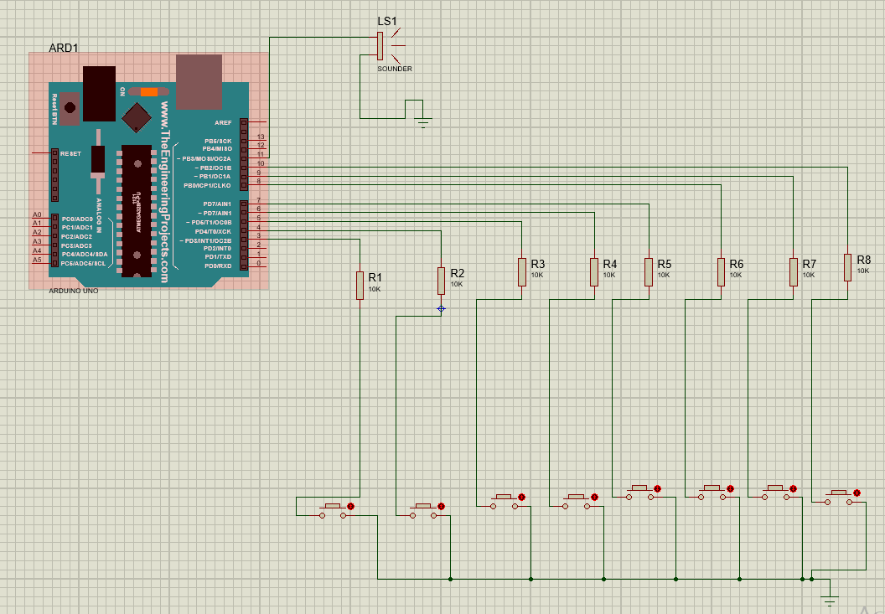

## 3.4 Algorithm

Step 1: Start

Step 2: Initialize Arduino and components.

Step 3: Connect coin to digital input pins and speaker to digital output pin and ground pin.

Step 4: Read coin strip pins to detect if any strip is touched.

Step 5: If a strip is touched, determine the note to play based on the strip and use tone() to play the note.

Step 6: Repeat steps 5-8 to continuously detect and play notes while strips are touched.

Step 7: If no strips are touched, go back to step 5 to continue detecting.

Step 8: End

## 3.4 Flowchart

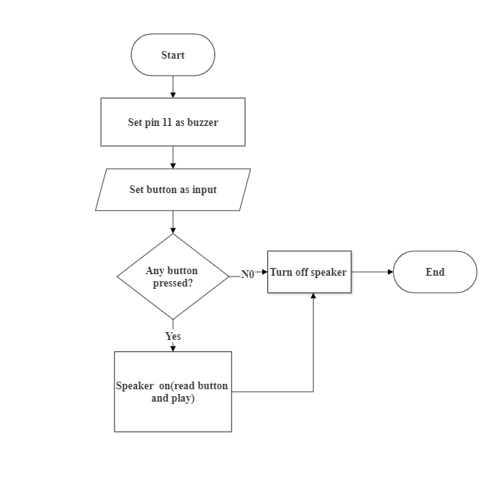

## 3.5 Gantt Chart

|  |  |  |  |  |  |  |
| --- | --- | --- | --- | --- | --- | --- |
| Task Name | 2022-2023 | | | | | |
| **November** | **December** | **January** | **February** | **March** | **April 30** |
| System Analysis |  |  |  |  |  |  |
| System Design |  |  |  |  |  |  |
| Coding and System  Implementation |  |  |  |  |  |  |
| Debugging and Testing |  |  |  |  |  |  |
| Documentation |  |  |  |  |  |  |

# CHAPTER 4: SYSTEM DEVELOPMENT AND IMPLEMENTATION

## 4.1 Programing platform (Tools and technologies used)

### 4.1.1 Software Specifications

Computer software specification we have used for development:

* Operating System: Windows 10
* Software: Keil and Proteus
* Programming Language: C

### 4.1.2 Hardware Specifications

Computer hardware specification we have used for development:

* Processor: Intel i5
* RAM: 16 GB
* SSD: 512 GB

# CHAPTER 5: CONCLUSION AND FUTURE ENHANCEMENT

## 5.1 Conclusion

In this documentation we have tried to explain every individual's topic clearly as per our project. We cannot justify anything either it is easier or difficult, it depends on how we take it and either we show our interest or not to do such things. Like as same in spite of some difficulties that we have found in our project we did it with our keen interest and gained new skills and experience which will be helpful to our future project and career and this project has really been helpful to us in gaining valuable experience of using an embedded system and c programming.

As we know that no program can be 100% reliable and efficient. So, there are also some drawbacks from our system like it cannot perform all the required function as of professional one. It is simply a program for Mini Piano. It is a user-friendly as it is easy and fun .Some of the important things we learned from this project:

1. We learned to use ATmega328P Microcontroller and create embedded system and hardware components.
2. We learned how the microcontroller works practically rather than theory.

## 5.2 Limitation

1. Mini Piano typically do not produce the same level of sound quality as traditional pianos or digital keyboards.
2. Limitations in terms of the number of keys, the range of notes, and the available functionalities.
3. The keys may not have the same level of responsiveness, touch sensitivity, or dynamic range, which can affect the expressiveness and nuance of the performance.
4. The materials used in constructing the Mini Piano may not be as durable or resilient for frequent transport or rough handling, which can impact its portability and ease of use in different locations.

## 5.3 Future Enhancement

1. We will add more tone and key to be a complete piano.
2. User interface using external components such as an LCD screen.
3. Design and assemble a simple electronic circuit using components such as resistors and speakers.

# REFERENCES

* Balaguruswamy, E(2011). *Programming in C.* New Delhi, Tata McGraw Hill Education Private Limited.
* <https://www.youtube.com/watch?v=sqQzIN7G6Oc>
* https://www.hackster.io/Barqunics/paper-piano-with-arduino-e27da7

# CODE

#include <CapacitiveSensor.h>

#define buzzer 11

// Set the Send Pin & Receive Pin.

CapacitiveSensor cs_12_3 = CapacitiveSensor(12,3);

CapacitiveSensor cs_12_4 = CapacitiveSensor(12,4);

CapacitiveSensor cs_12_5 = CapacitiveSensor(12,5);

CapacitiveSensor cs_12_6 = CapacitiveSensor(12,6);

CapacitiveSensor cs_12_7 = CapacitiveSensor(12,7);

CapacitiveSensor cs_12_8 = CapacitiveSensor(12,8);

CapacitiveSensor cs_12_9 = CapacitiveSensor(12,9);

CapacitiveSensor cs_12_10 = CapacitiveSensor(12,10);

CapacitiveSensor cs_12_13= CapacitiveSensor(12,13);

void setup()

{

// turn off autocalibrate on channel 1 - just as an example

cs_12_3.set_CS_AutocaL_Millis(0xFFFFFFFF);

cs_12_4.set_CS_AutocaL_Millis(0xFFFFFFFF);

cs_12_5.set_CS_AutocaL_Millis(0xFFFFFFFF);

cs_12_6.set_CS_AutocaL_Millis(0xFFFFFFFF);

cs_12_7.set_CS_AutocaL_Millis(0xFFFFFFFF);

cs_12_8.set_CS_AutocaL_Millis(0xFFFFFFFF);

cs_12_9.set_CS_AutocaL_Millis(0xFFFFFFFF);

cs_12_10.set_CS_AutocaL_Millis(0xFFFFFFFF);

cs_12_13.set_CS_AutocaL_Millis(0xFFFFFFFF);

}

void loop()

{

// Set the sensitivity of the sensors.

long touch1 = cs_12_3.capacitiveSensor(1000);

long touch2 = cs_12_4.capacitiveSensor(1000);

long touch3 = cs_12_5.capacitiveSensor(1000);

long touch4 = cs_12_6.capacitiveSensor(1000);

long touch5 = cs_12_7.capacitiveSensor(1000);

long touch6 = cs_12_8.capacitiveSensor(1000);

long touch7 = cs_12_9.capacitiveSensor(1000);

long touch8 = cs_12_10.capacitiveSensor(1000);

long touch9= cs_12_13.capacitiveSensor(1000);

// When we touched the sensor, the buzzer will produce a tone.

if (touch1 > 1000){

tone(buzzer,400);

}

if (touch2 > 1000){

tone(buzzer,270);

}

if (touch3 > 1000){

tone(buzzer,650);

}

if (touch4 > 1000) {

tone(buzzer,900);

}

if (touch5 > 1000){

tone(buzzer,1100);

}

if (touch6 > 1000){

tone(buzzer,1300);

}

if (touch7 > 1000){

tone(buzzer,1670);

}

if (touch8 > 1000){

tone(buzzer,2000);

}

if (touch9 > 1000){

tone(buzzer,2050);

}

// When we didn't touch it, no tone is produced.

if (touch1<=1000 & touch2<=1000 & touch3<=1000 & touch4<=1000 & touch5<=1000 & touch6<=1000 & touch7<=1000 & touch8<=1000 & touch9<=1000)

noTone(buzzer);

delay(10);

}